Text Component

Properties Tab

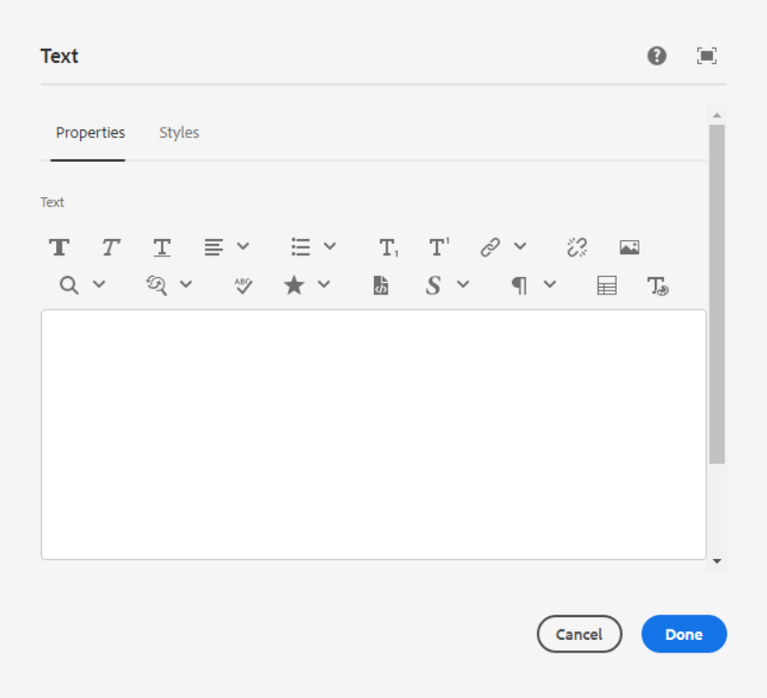

1. **Bold**



1. **Italic**



1. **Underline**



1. **Justify**

* **Align text Left**
* **Center Text**
* **Align text right**
* **Justify**

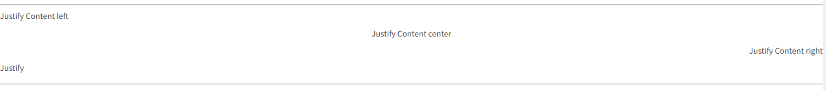

1. **Lists**

* **Numbered List**
* **Bullet List**
* **Outdent**
* **Indent**

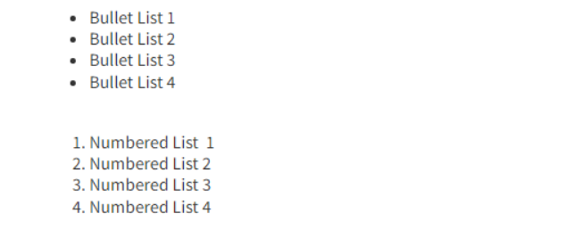

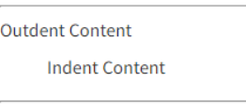

1. **Subscript**
2. **Superscript**

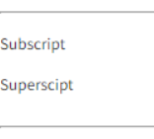

1. **Hyperlink**

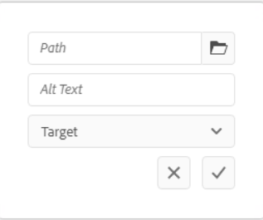

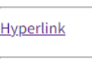

1. **Unlink**
2. **Image**
3. **Find**

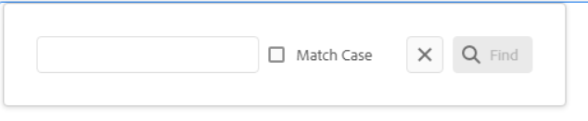

1. **Replace**

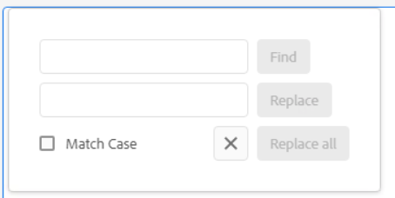

1. **Check Spelling**
2. **Special Character**
3. **Source Edit**
4. **Styles**

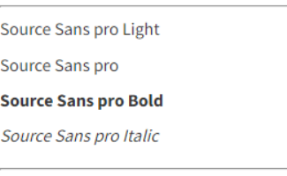

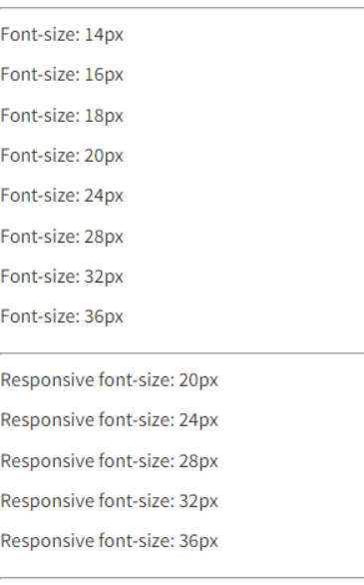

1. **Paragraph Formats**

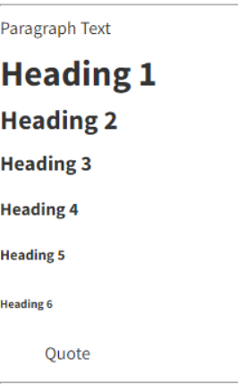

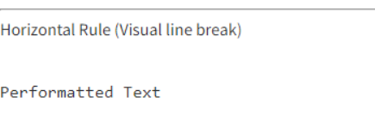

1. **Table**

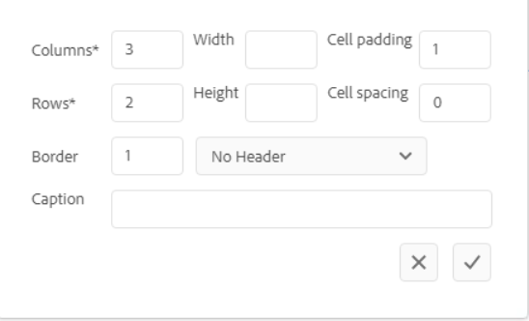

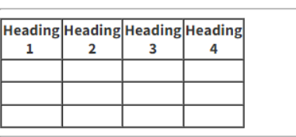

1. **Select Font –** Select the text and click on the select font the below popup will be shown. We can able to add font size, text color, and text background color.

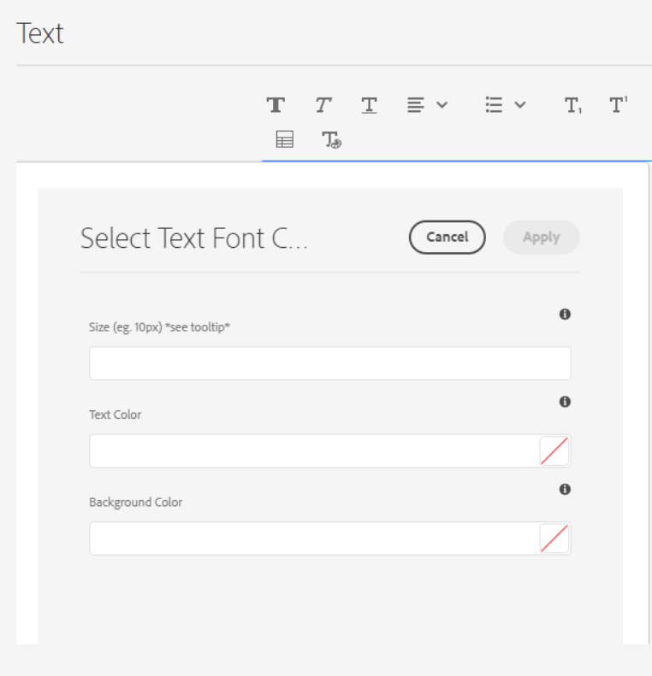

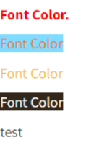

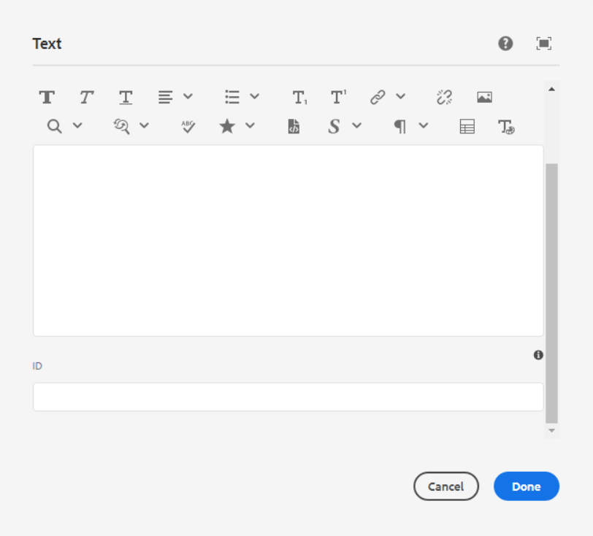

**ID** – HTML ID attribute to apply to the component.

Styles Tab

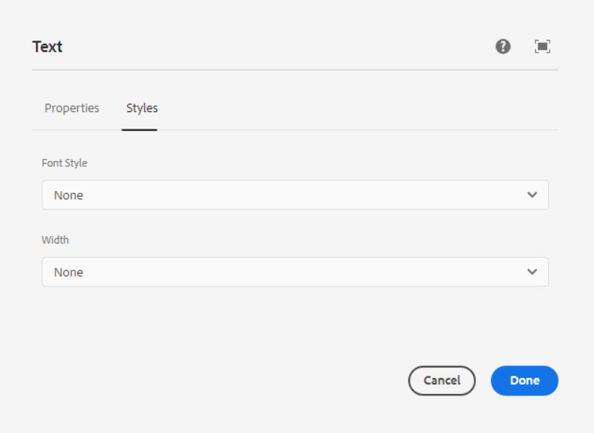

**Font Style -** In this dropdown below list of font styles are available, we can select one font styles as per our requirement.

1. Font weight – 300
2. Font weight – 400
3. Font weight – 500
4. Font weight – 600

**Width –** If we select this option from the dropdown then the responsive text will be shown 100% of the width

* Select Full width

For E.g.

**Page Reference** - <https://www.ancestry.com/corporate/newsroom/press-releases/ancestry-reunites-family-torn-apart-slavery-using-uncovered-letters>



In Responsive, contact us text will take 100% of width and goes on the second line.

